2. KOAN Leadership Report  
With suggestions for development

The report consists of **two** sections:

**The first section** presents a list of 10 strengths that the respondent can capitalise on in his personal growth as a leader.

**Example:**

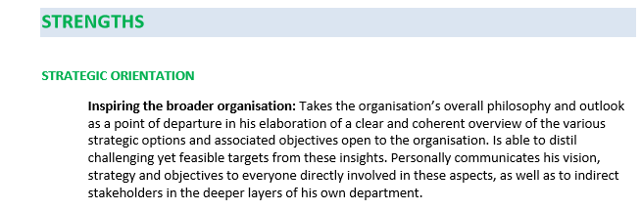

**The second section** presents a list of 5 areas for development with the development suggestions that may hinder the respondent in his personal growth as a leader, or even get in the way of his career development.

**Example:**

